Vehicle Damage Assessment

Dear valued customer, we thank you for the opportunity to serve you. We are very sorry that a bear destroyed your car, and we can fully appreciate how much of an impact on a person. Please view the details below, which provide the full details related to your most recent vehicle damage assessment. Review the information, and feel free to call us with any questions. Your assigned customer support representative will be in contact within 7-10 business days to provide you with further information related to your case.

Customer Name: {{CONTACT_NAME}}
Prepared By: {{OWNER_NAME}}
Case Date: {{CASE_CREATEDDATE\@ "MM-dd-yyyy }}
Vehicle Make: {{CASE_VEHICLE_MAKE}}
Vehicle Model: {{CASE_VEHICLE_MODEL}}
Vehicle Year: {{CASE_YEAR}}

Question | Answer
{{TableStart:vdafront}}{{DISCO__ANSWER__CDISCO__QUESTION_LABEL}} | {{DISCO__ANSWER_ANSWER}}{{TableEnd:vdafront}}

Front of Vehicle

Rear of Vehicle
Question | Answer
{{TableStart:vdarear}}{{DISCO__ANSWER__CDISCO__QUESTION_LABEL}} | {{DISCO__ANSWER_ANSWER}}{{TableEnd:vdarear}}

Left Side of Vehicle

Question | Answer
{{TableStart:vdaleft}}{{DISCO__ANSWER__CDISCO__QUESTION_LABEL}} | {{DISCO__ANSWER_ANSWER}}{{TableEnd:vdaleft}}

Right Side of Vehicle
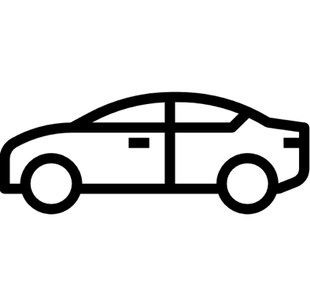

Question | Answer
{{TableStart:vdaright}}{{DISCO__ANSWER__CDISCO__QUESTION_LABEL}} | {{DISCO__ANSWER_ANSWER}}{{TableEnd:vdaright}}

Final Summary / Expert Analysis

Question | Answer
{{TableStart:vdafinalsummary}}{{DISCO__ANSWER__CDISCO__QUESTION_LABEL}} | {{DISCO__ANSWER_ANSWER}}{{TableEnd:vdafinalsummary}}

Photos From Assessment
{{TableStart:vdaphotos}}{{IMAGE:LATESTPUBLISHEDVERSION_IMAGE_URL:W=650}}{{TableEnd:vdaphotos}}

